ASDM Assignment 1

**backog**

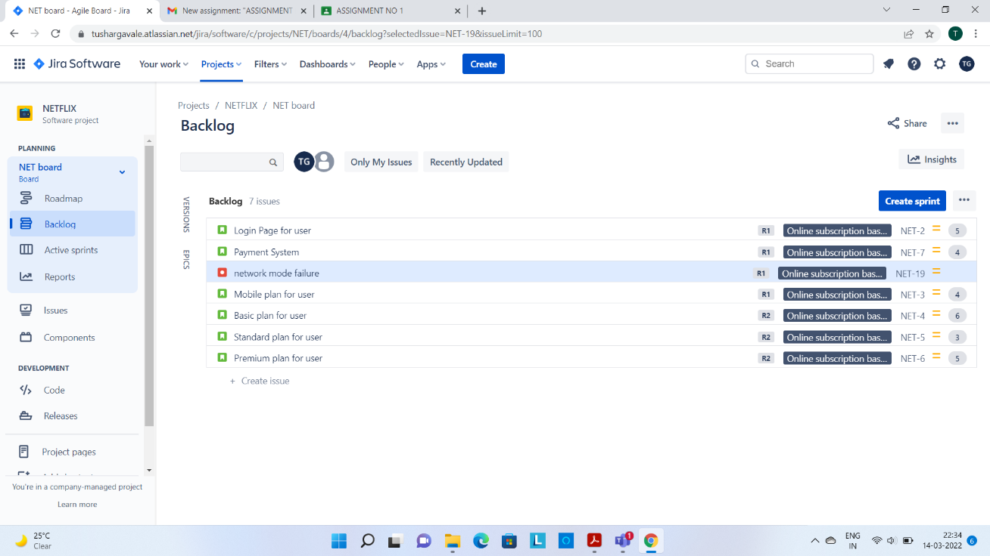

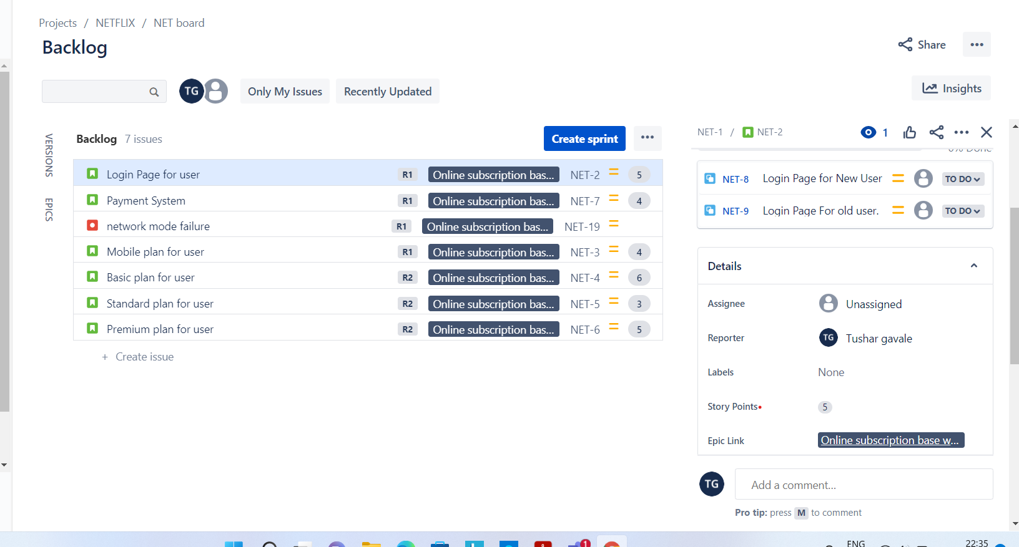

BURN DOWN CHART (Remaining time estimate)

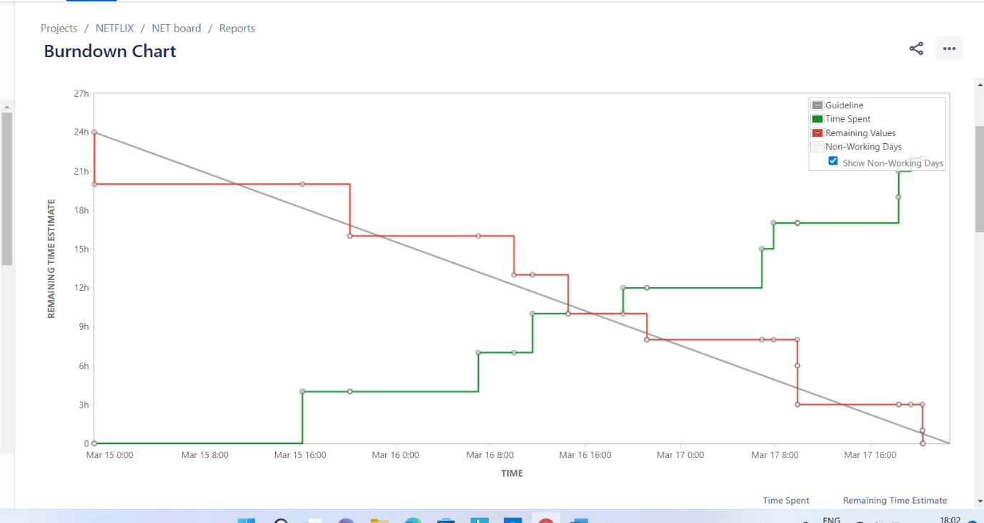

BURN DOWN CHART (Story Point)

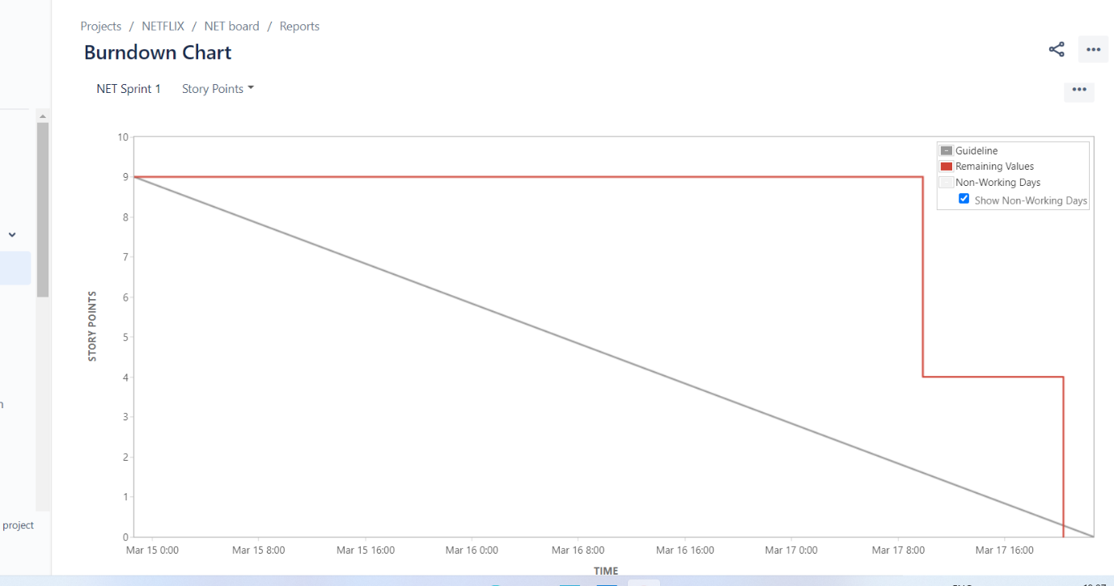

**BURN UP CHART (original time estimate)**

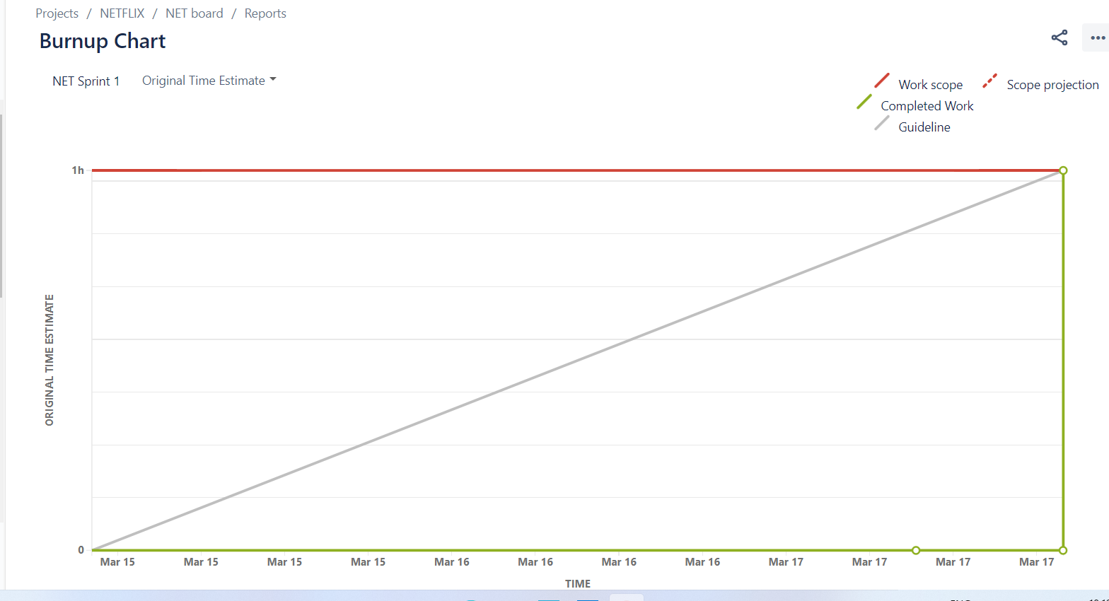

**BURN UP CHART (Issue Count)**

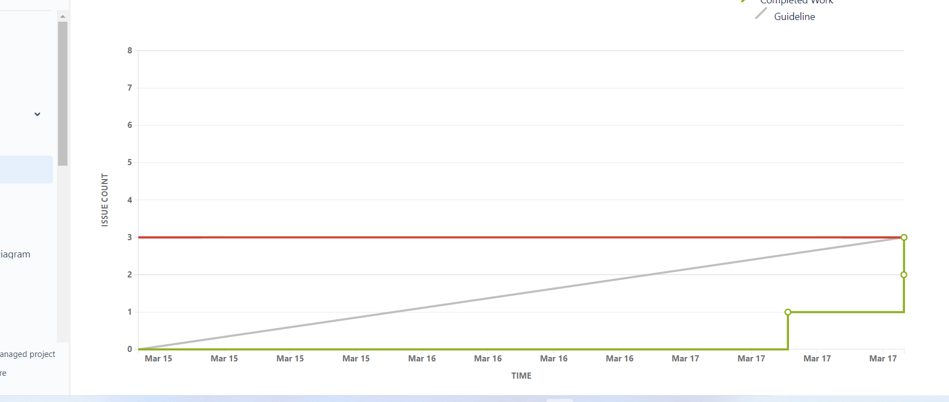

**SPRING REPORT**

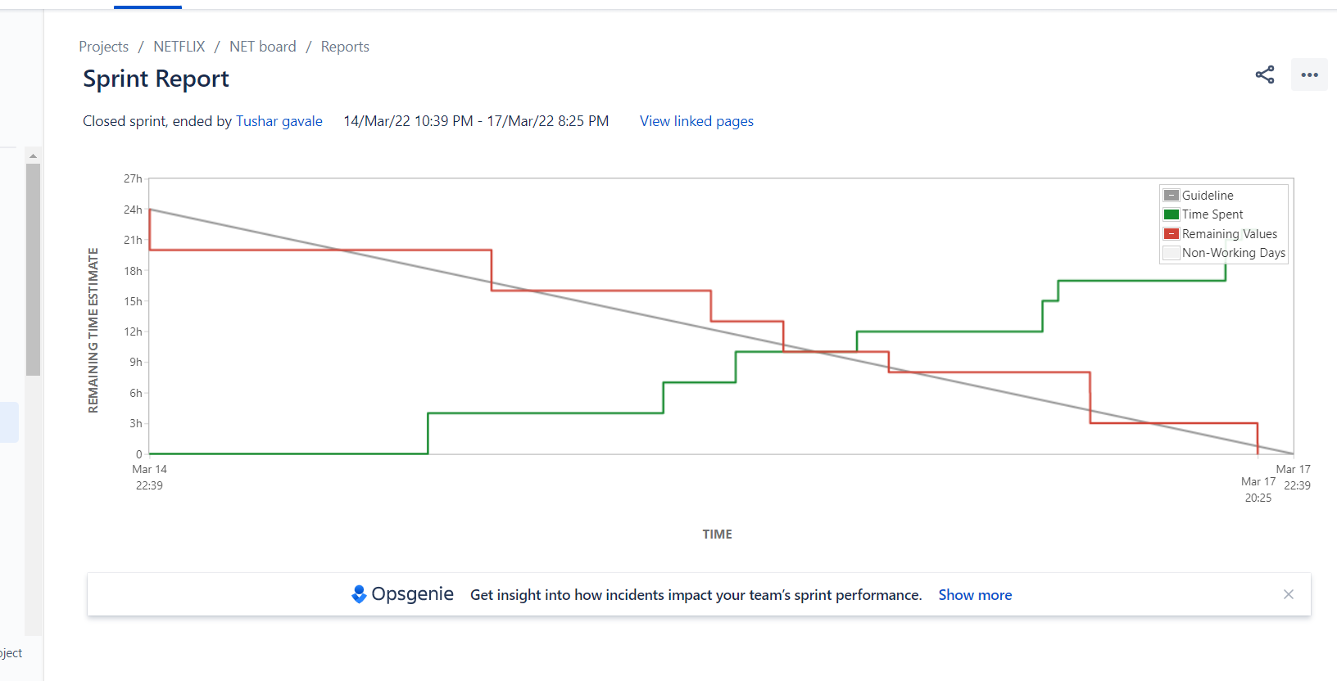

**VELOCITY CHART**

